Knauf Industries Additive Validates New Thermo-Mechanical Simulation in 3DXpert for High Accuracy Printing - Less waiting times, Higher Dimensional Accuracy

As part of the Beta testing of the upcoming thermo-mechanical simulation and compensation, Knauf Industries Additive evaluated the new capability and compared it to the existing mechanical simulation (pure inherent strains analysis). Knauf has been a simulation power user for more than eight years, combining extensive Additive Manufacturing (AM) and simulation know-how to push productivity and efficiency.

The EPP Tooling Technology
Knauf Industries Additive uses additive manufacturing to produce tools for particle foam (EPP) applications with integrated, component-near cooling. Thanks to a patented design, up to 80% of the tool weight can be saved compared to conventionally manufactured alternatives. This advanced technology has more than doubled the productivity of EPP machines and halved CO₂ emissions, specifically reducing CO₂ output by three tons per ton of produced EPP. This tooling technology is crucial for achieving Knauf Industries' sustainability goals (50% CO₂ reduction by 2032; carbon neutrality by 2045).
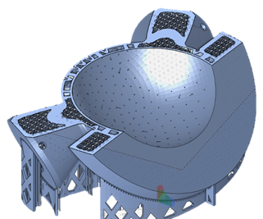
Figure 1: Cross section of the printed evaluation part with cooling plane and lattice structure

Deformation Compensation in Industrial Production Environment
At full capacity, Knauf can design and print up to 180 tools per year (each composed of multiple components). Last year, over 160 print jobs of large components were printed, resulting in 80 final EPP tools for production. For every one of these jobs, process-induced deformations were simulated and automatically compensated for in 3DXpert Mechanical Simulation. A special requirement for parts like the ones needed for EPP applications is the accurate consideration of regions with complex and filigree internal structures, such as cooling channels and hollow lattice-filled regions. Within 3DXpert Simulation, such regions can be homogenized: Complex regions are approximated by simplified envelopes with effective material properties, regions are meshed as solid material and simulated with appropriately adapted material properties, which significantly reduces the computational resources and time required while maintaining the necessary prediction accuracy compared to simulating the original filigree structures.

New Module: Thermo-Mechanical Simulation
Achieving high geometrical accuracy in metal additive manufacturing is challenging, primarily due to two main drivers of deformation: Micro-Weld Stresses (Inherent Strain), where the melting and rapid solidification of each individual laser track introduces localized stress, leading to overall tension and displacement; and Global Thermal Effects, where the cumulative heat input causes the entire part, or massive sections thereof, to undergo repeated cycles of heating and cooling, leading to macroscopic shrinkage and deviations.
As part of this evaluation, a demonstrator for leak testing was manufactured in 316L using both the current uncoupled simulation and the new coupled thermo-mechanical simulation. The Difference is that while the standard simulation primarily accounts for welding-induced distortion, the new coupled module combines inherent strain simulation with thermal simulation to fully incorporate both the micro-weld stresses and the global thermal effects (such as overall shrinkage in overheated areas. This new module enables the production of parts with significantly higher dimensional accuracy by compensating for close to 100% of dimensional distortion attributed to macro and micro level phenomena occurring during printing. To achieve this level of precision with the existing uncoupled simulation, long cooling times or a high number of support structures are typically required, which is often not economically viable for serial production. Crucially, the new simulation significantly reduces or even eliminates – the need for such measures, opening up new potential for productivity gains.

Demo Component and Result
Calibration of the Thermo-Mechanical simulation was done based on a single previous print of specific calibration specimens similar to the proven cantilever calibration.
The printed component, including support structures, is roughly 100mm x 140mm x 100mm. The two specimens with different compensation approaches were printed in a single print job without previous trials and adaptation of simulation parameters. This resulted in a simulated heat-up of up to 470°C. Normally, such high temperatures would require countermeasures like increased layer time or additional supports to ensure accuracy with the standard mechanical simulation, but none of these were implemented to show the new module's potential. The Result clearly demonstrates the ability to compensate for both the welding distortions as well as the macroscopic shrinkage even in complex and large components.
Without taking predeformation into account, the parts deform/shrink by up to 0.7mm.
Predeformating the parts without taking shrinkage into account resulted in a residual deformation of 0.35mm in large areas.
When weld deformation and shrinkage are compensated for, most of the part has a deformation of less than 0.1mm. Only the underside of the outer edge has deformations of around 0.2mm in some places.

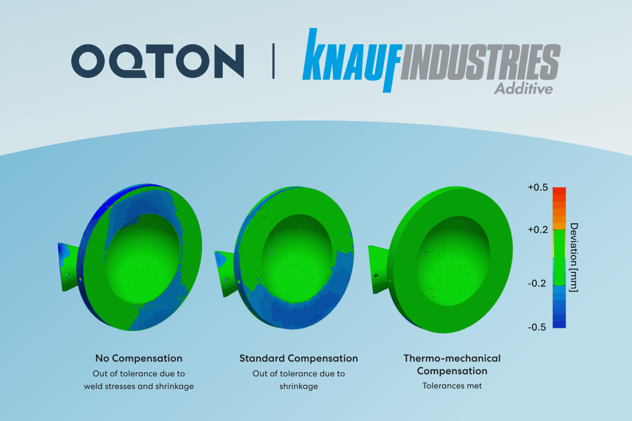
Figure 2: The middle and the right scans show the comparison of the nominal geometry with the respective printed specimens.

